<Country name>
EVM assessment
<Assessment dates>

Findings and recommendations of
the assessment team

<Optional: insert image>

<report date>

Note: Double click on the footer strip. Delete all logos except the one that applies to the organization supporting the assessment – e.g. WHO

Abstract
This report presents the findings of an Effective Vaccine Management (EVM) assessment of <country name> which was carried out in <month(s)> <year>. <X> storage and health facilities were visited and their records were assessed for the 12 month period <date> to <date>.
An EVM assessment provides a systematic analysis of strengths and weaknesses across the supply chain; it is part of the EVM process which is designed to embed good vaccine storage and distribution practices.
<Include a short paragraph summarizing the most important strengths and weaknesses identified, the recommendations made to address those weaknesses, and any strategic recommendations.

Contents
Executive summary 5
Acronyms 6
Acknowledgements 6
Terms of reference 7
Related documents 7
Assessment team 7
1. Introduction 7
1.1 Introduction to EVM 7
1.2 Site selection 9
1.3 Assessment types used 9
1.4 Tool version used 9
1.5 Places visited 9
2. Country background 9
2.1 Organization of immunization services 9
2.2 Immunization schedule and suppliers 10
2.3 Planned vaccine introductions 10
2.4 Vaccine volume data 10
3. Supply chain overview 10
3.1 Logistics structure 10
3.2 Fixed infrastructure 10
3.3 Transport infrastructure 10
3.4 Recording and reporting systems 10
4. Previous assessments 10
4.1 Key assessment findings 10
4.2 Key recommendations 10
4.3 Progress on recommendations 10
5. Supply chain development 11
6. Assessment findings and recommendations 11
6.1 Primary level 11
E1: Vaccine arrival procedures 11
E2: Temperature monitoring 11
E3: Storage and transport capacity 11
E4: Buildings, equipment and transport 11
E5: Maintenance 11
E6: Stock management 11
E7: Distribution 11
E8: Vaccine management 11
E9: MIS and supportive functions 11
6.2 Sub-national level 11
E2: Temperature monitoring 11
E3: Storage and transport capacity 12
E4: Buildings, equipment and transport 12
E5: Maintenance 12
E6: Stock management 12
E7: Distribution 12
E8: Vaccine management 12
E9: MIS and supportive functions 12
6.3 Lowest delivery level 12
E2: Temperature monitoring 12
E3: Storage and transport capacity 12
E4: Buildings, equipment and transport 12
E5: Maintenance 12
E6: Stock management 12
E7: Distribution 12
E8: Vaccine management 12
E9: MIS and supportive functions 12
6.4 Service delivery level 13
E2: Temperature monitoring 13
E3: Storage and transport capacity 13
E4: Buildings, equipment and transport 13
E5: Maintenance 13
E6: Stock management 13
E7: Distribution 13
E8: Vaccine management 13
6.5 Global recommendations 13
Annex 1 – Detailed recommendations 14
Annex 2 – Improvement Plan 15
<Other annexes as needed> 16
Revision history 17

Executive summary
<The executive summary should be no more than three pages, and should include:
- a short description of the rationale and process of the EVM assessment (example text included below),
- a summary of the key strengths and weaknesses identified,
- a summary of the key recommendations made to address the identified weaknesses, and,
- any strategic recommendations.
Include tables and/or charts, showing at least the mean criteria (or category) scores for each level.>
With the rising cost of vaccines and the greater storage capacity now required at every level of the cold chain, countries must maintain lower stock levels, reduce wastage, accurately forecast vaccine requirements, and prevent equipment break-downs. This requires a consistently high standard of supply chain management, which can only be achieved if all of the links in the supply chain comply with current good storage and distribution practices. The EVM initiative provides the materials needed to monitor and assess vaccine supply chains and to help countries to improve their supply chain performance.
An EVM assessment identifies the key strengths and weaknesses in nine different areas of vaccine management at each of four levels of the vaccine supply chain, and makes recommendations to address any weaknesses. The four supply chain levels are:
PR | Primary level
SN | Sub-national level
LD | Lowest distribution level
SP | Service point level
The nine areas (criteria) of vaccine management are:
E1 | Vaccine & commodity arrival procedures
E2 | Vaccine storage temperatures
E3 | Cold & dry storage capacity
E4 | Buildings, CC equipment & transport
E5 | Maintenance
E6 | Stock management
E7 | Effective distribution
E8 | Good vaccine management practices
E9 | Information systems and supportive management functions
A systematic sample of vaccine storage facilities is surveyed and the data is collated and assessed by supply chain level.

Acronyms
Note: Adapt as necessary and add country-specific vaccine acronyms
°C | degrees centigrade
AD | Auto-disable (syringe)
BCG | bacille Calmette-Guérin (tuberculosis vaccine)
CC | Cold Chain
DTP | Diphtheria, Tetanus and Pertussis vaccine
EEFO | Earliest-Expiry-First-Out
EPI | Expanded Programme on Immunisation
EVM | Effective Vaccine Management
FIC | Fully Immunized Child
GAVI | Global Alliance for Vaccines and Immunisation
HepB | Hepatitis B vaccine
Hib | Haemophilus influenzae b
ILR | Ice-lined refrigerator
JE | Japanese encephalitis vaccine
LD | Lowest delivery level store
MoH | Ministry of Health
OPV | Oral Polio Vaccine
PR | Primary store
SN | Sub-national store
SOP | Standard Operating Procedure
SP | Service point (health facility)
UNICEF | United Nations Children’s Fund
VAR | Vaccine Arrival Report
VVM | Vaccine Vial Monitor
WHO | World Health Organization

Acknowledgements
This document has been prepared by <names and affiliations.>
The team would like to thank <list of government and partner organizations and specific named individuals.>

Terms of reference
<Describe the team’s terms of reference.>

Related documents
The following spreadsheets and documents were used in the preparation of this report:
Excel workbooks:
<List EVM and related workbooks, including EVM Site Selection Tool, EVM Assistant, etc.>
Documents:
<List any related documents, including the recommendations and the improvement plan.>
Images :
<List any attached images or movie clips.>

Assessment team
<List members of the assessment team and their affiliations.>

Introduction

Introduction to EVM
The EVM process is first and foremost about embedding good storage and distribution practices. The package has been designed so that it can be used both as an assessment tool for the systematic analysis of strengths and weaknesses across the supply chain but also as a supervisory aid to monitor and support the long-term progress of individual facilities.
Good storage and good distribution practices for temperature-controlled pharmaceuticals and other products are increasingly the focus of national and international legislative and regulatory control in both developed and developing countries. EVM follows the well-established principles of quality management used throughout the industrialised world – for example the ISO 9000 series of quality standards.
EVM is designed to help countries to develop strength-in-depth by building a culture of quality based on a structured approach to supply chain management, monitoring and record-keeping. Figure 1 illustrates the hierarchy of documentation needed to support this approach. EVM covers the yellow shaded area of the diagram.
Figure 1 – Quality Management documentation
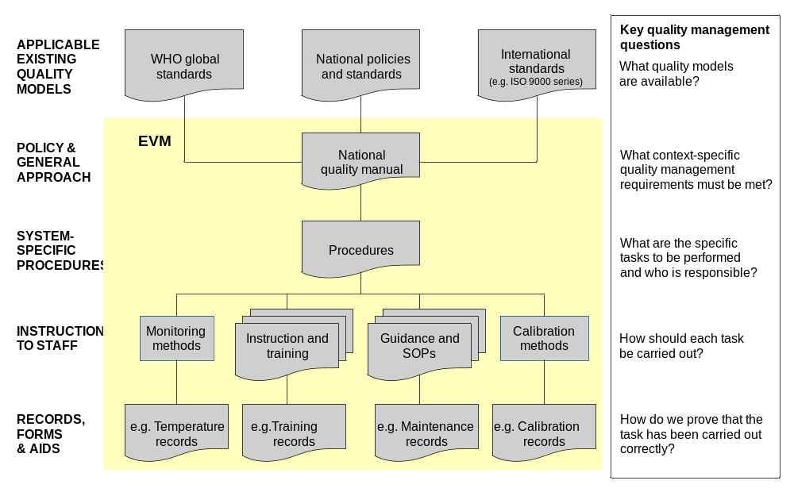
The EVM tool is used to assess the quality and sufficiency of the seven component elements of an effective supply chain: buildings; storage and transport capacity; cold chain equipment; vehicles; repairs and maintenance; training, and the management systems needed for the effective operation and control of the system.
An EVM assessment uses a structured questionnaire; this questionnaire is designed to allow evaluation of four distinctly different levels in the supply chain, as follows:
- The primary (PR) level store (generally the national store) where vaccine is received directly from the vaccine manufacturer or from an international supplier such as UNICEF Supply Division. Typically vaccine is stored in large cold rooms and freezer rooms. <Describe how this relates to the target country>.
- The sub-national (SN) level where vaccine is received from the primary store, stored for an agreed period, and then distributed to lower levels stores or to health facilities. These stores may have a cold room and/or a number of vaccine refrigerators and freezers. <Describe how this relates to the target country>.
- The lowest delivery level (LD) store where vaccine is received, either from the primary store or from a sub-national store. From this point it is distributed directly to service delivery points. The lowest delivery level does not normally provide any immunization services. <Describe how this relates to the target country>.
- Service delivery points (SD) such as health centres and health posts, where vaccine is stored for a short time before delivery to the target population – usually in a single refrigerator, but also, on a very short-term basis, in vaccine cold boxes or vaccine carriers. Each service delivery point may distribute vaccine to other service delivery points. <Describe how this relates to the target country.>
The EVM tool is based on nine basic criteria, each of which is divided into a number of requirements and sub-requirements; together these characterize the fundamental qualities of a good vaccine supply chain. Compliance with each of these sub-requirements is tested using a series of tightly focussed questions, which are numerically scored.
A single common list of requirements, sub-requirements and questions is used for the entire supply chain. The EVM tool automatically filters this common list to create questionnaires that are specifically directed at each of the four levels described above. These level-specific questionnaires can be further filtered to pick out only the critical indicators. In this way an assessor can choose to carry out a full EVM assessment or a rapid review assessment which is based on the critical indicators alone.
In addition to the overall filtering process, the tool dynamically adjusts the questions offered in response to the assessor’s answers to certain country- or level-specific conditions. For example, if refrigerated trucks are used to distribute vaccines, a set of questions is offered covering this type of equipment.
In its current form, the tool summarises assessment results in two ways:
- The score achieved against each of the criteria that is relevant to the level being assessed.
- The score achieved against indicators classified in accordance with seven categories of question – those relating principally to: buildings; storage capacity; cold chain equipment; vehicles; repairs and maintenance; training, and management.
Note that management and training categories play an important role in many of the criteria scores.

Site selection
<Describe how the assessment sites were chosen – generally this will be done using the EVM Site Selection Tool.>
<Describe any deviations from random sampling, including the exclusion of sites and the reasoning behind this.>

Assessment types used
<Describe which levels were assessed with the Full version of the tool and which with the Review version.>

Tool version used
<Describe which version of the EVM tool was used, and in which language.>

Places visited
<Describe which major locations/areas of the country were visited and provide a map showing these places.>

Country background
<Briefly describe the country background, including population details, geographical and other challenges, etc.>

Organization of immunization services
<Describe how immunization services are provided, including brief details of any outsourcing arrangements, relevant organograms, etc.>

Immunization schedule and suppliers
<Tabulate the schedule and identify the principal vaccine and commodity suppliers, including in-country manufacturers.>

Planned vaccine introductions
<Describe forthcoming new vaccine introductions.>

Vaccine volume data
<Include a table showing the vaccine volume data for each facility used in the cold chain capacity analyses (including the effect of any new vaccine introductions). Describe any important assumptions made in the analyses. These data may be extracted from the EVM Assistant.>

Supply chain overview

Logistics structure
<Describe how the in-country logistics are organized (in theory), preferably with a chart to illustrate this.>

Fixed infrastructure
<Describe the fixed infrastructure (buildings, CC equipment, generators, etc.) at each of the assessed levels, working from primary level downwards. If possible, include tables itemising existing cold chain equipment, capacities and ages. Illustrate with relevant photographs wherever possible. A plan of the primary store(s), drawn roughly to scale, is also very useful.>

Transport infrastructure
<Describe the transport infrastructure working from primary level downwards. Illustrate with relevant photographs wherever possible.>

Recording and reporting systems
<Describe existing recording and reporting systems, including temperature monitoring, stock control systems, vaccine distribution plans, etc. Include examples of key forms where relevant.>

Previous assessments
<List any previous assessments and then complete sections 4.1 to 4.3. Depending on the number and type of assessments you may wish to repeat the 4.1 to 4.3 sequence of headings for each assessment>.

Key assessment findings

Key recommendations

Progress on recommendations

Supply chain development
<Describe the outcome of any recent strategic supply chain review and any supply chain development plans.>

Assessment findings and recommendations
This section presents the assessment findings, the analysis of those findings, and the consequent recommendations, on a level-by-level and criterion-by-criterion basis. Global recommendations, applicable to all levels, are presented in section 6.5. To facilitate the preparation of the improvement plan, all recommendations are presented together in Annex 1.

Primary level
<Use EVM spider charts, column charts and/or tables to illustrate the findings of the assessment of the primary (PR) level. Describe the assessment findings and consequent recommendations on a criterion-by-criterion basis.>

E1: Vaccine arrival procedures

E2: Temperature monitoring

E3: Storage and transport capacity

E4: Buildings, equipment and transport

E5: Maintenance

E6: Stock management

E7: Distribution

E8: Vaccine management

E9: MIS and supportive functions

Sub-national level
<Use EVM spider charts, column charts and/or tables to illustrate the findings of the assessment of the sub-national (SN) level. Describe the assessment findings and consequent recommendations on a criterion-by-criterion basis.>

E2: Temperature monitoring

E3: Storage and transport capacity

E4: Buildings, equipment and transport

E5: Maintenance

E6: Stock management

E7: Distribution

E8: Vaccine management

E9: MIS and supportive functions

Lowest delivery level
<Use EVM spider charts, column charts and/or tables to illustrate the findings of the assessment of the lowest delivery (LD) level. Describe the assessment findings and consequent recommendations on a criterion-by-criterion basis.>

E2: Temperature monitoring

E3: Storage and transport capacity

E4: Buildings, equipment and transport

E5: Maintenance

E6: Stock management

E7: Distribution

E8: Vaccine management

E9: MIS and supportive functions

Service delivery level
<Use EVM spider charts, column charts and/or tables to illustrate the findings of the assessment of the service delivery point (SD) level. Describe the assessment findings and consequent recommendations on a criterion-by-criterion basis.>

E2: Temperature monitoring

E3: Storage and transport capacity

E4: Buildings, equipment and transport

E5: Maintenance

E6: Stock management

E7: Distribution

E8: Vaccine management

Global recommendations

Annex 1 – Detailed recommendations
<Please list all recommendations, from section 6.1 to section 6.5, in the table below (add rows as required).>
No. | Levels | Criterion | Recommendation
1 | PR, SN, LD | E3 | …
2 | SN | E2 | …
3
4
5
6
7
8
9
10
11
12

Annex 2 – Improvement Plan
<If the improvement plan is finalised before the completion of the main report it should be included here. Please use the standard Excel template provided.>

<Other annexes as needed>

Revision history
Date | Change summary | Reason for change | Approved
1 July 2011 | Section 2.1, p 7 amended | Comments received
26 June 2012 | General version 2 revision:  - a standard abstract has been added,  - the Executive summary is now the first item in the table of contents,  - brief guidelines as to what the executive summary should contain have been added,  - a short standard description of the rationale and process of the EVM assessment has been added to the Executive summary,  - instructions have been added to the Site selection sub-section to include a description of any deviations from random sampling,  - a new section, Previous assessments, has been added, with sub-sections Key assessment findings, Key recommendations, and Progress on Recommendations,  - a new section, Supply chain development, has been added,  - the old sections Overall Findings and Detailed analysis and conclusions have been combined into one section Assessment findings and recommendations, in which the findings and recommendations are presented on a level-by-level and criterion-by-criterion basis, and,  - the annex Detailed recommendations now has a tabular format (to facilitate the development of an improvement plan). | Arising from comments received during and after the NY CCL workshop in Nov-Dec 2011.

For example, the first criterion – vaccine arrivals – is only relevant at the primary level. Other criteria are also filtered out at lower levels.

